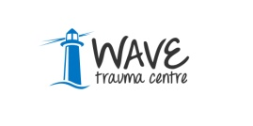
For the care and support of those
bereaved, traumatised or injured as a result of the ‘Troubles’/Conflict in Northern Ireland

Applicant Information Pack

Trauma Education Officer
Full Time 37.5 hours
Part Time 22 hours

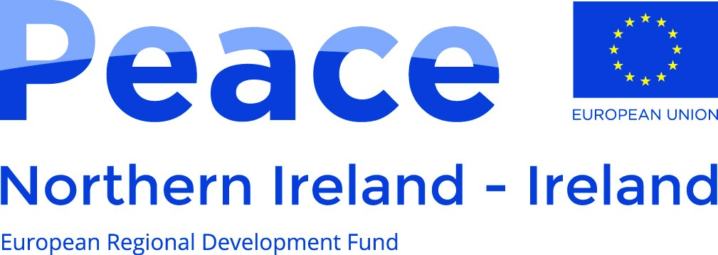

A project supported by the European Union’s PEACE IV Programme,
managed by the Special EU
Programmes Body (SEUPB).
This post is funded by the Victims and Survivors Service through the Victims and Survivors Programme administered on behalf of the Executive Office.

Dear Applicant,

Role: Trauma Education Officer – Full Time Ref: TEO/FT/SEPT/19/
Trauma Education Officer – Part Time Ref: TEO/PT/SEPT/19/

Thank you for your interest in the above post.

Short listing will be completed on the basis of the information you provide on the application form, therefore please ensure you complete all relevant sections to help us make our decision. Please note that we do not accept CV’s.

Please find enclosed the following: -

- Our Mission and Values
- Job Description
- Personnel Specification
- Outline of Terms and Conditions
- Guidance Notes
- Employment Application Form and Monitoring Form (for completion).

We request that you complete and return this for statistical monitoring purposes.

For information on WAVE, please visit our website www.wavetraumacentre.org.

If you intend to complete and return the Application Form, please also complete and return the enclosed MONITORING QUESTIONNAIRE and place in an envelope. This will be treated in confidence. We request this information to help WAVE promote equality of opportunity in employment. Our recruitment policy operates on the merit principle i.e. we select the best person for the job, regardless of religious affiliation, political opinion, belief, age, race, gender, marital status, sexual orientation or disability.

We would like you to know that: -
Only the Application Form is considered by our Recruitment Panel, who shortlist and interview for vacancies. The Monitoring Questionnaire is confidential to our Monitoring Officer who uses it for compiling statistical information and is not seen by the Recruitment Panel.
If you have any questions regarding the information enclosed, please do not hesitate to contact us.

I look forward to hearing from you.

Yours faithfully

Tracey Shirlow
HR Manager

PLEASE NOTE: CLOSING DATE: Thursday 10th October at 1.00 pm
Hard Copy Completed forms should be returned to:
HR Manager, WAVE Trauma Centre,
5 Chichester Park South, Belfast, BT15 5DW

WAVE: Who we are?
WAVE, established in 1991, is a voluntary, cross community charitable organisation which offers care and support to anyone bereaved, traumatised or injured as a result of the Troubles/Conflict. The philosophy and ethos of the organisation is one of inclusiveness, providing care for anyone irrespective of religious, cultural or political belief. WAVE promotes a respect for life and an understanding of difference that is seen as enhancing rather than threatening. WAVE continually seeks creative ways of working through issues that have the potential to divide.
Over the years the violence in Northern Ireland has led directly to the deaths of over 3,600 people and resulted in over 40,000 serious injuries. The Cost of the Troubles Study (1997) estimated that, “At the very least 6,800 people have the experience of one of their immediate family - parent or sibling - being killed in a Troubles-related incident.” The true cost however, is much higher as the relatives of those killed and maimed have also suffered ill health, disruption of family relationships, impaired functioning, substance abuse and in some cases when their grief became intolerable, suicide.
Over the last twenty-five years the level of calls and referrals to WAVE has increased year on year. Referrals are received from those affected by violence more recently in addition to those injured, traumatised or bereaved across the last four decades. This indicates the necessity of providing the services offered by WAVE on a long-term basis.
To date WAVE has offered care and support to over 20,000 people, a cross section of adults, young people and children. WAVE works to utilise the benefit of every pound received in funding or donations for the benefit of clients. The organisation’s management cost is extremely low at 8%, well below the recommended national level of 15%. WAVE offers exceptional value for funders and strong professional services for clients.
WAVE has extensive community based Trauma Education Programmes. These programmes have been refined and developed over 20 years and offer students a range of options to meet their learning needs. Trauma Education includes:-

- Short Trauma Courses accredited by the School of Education at Queen’s University, Belfast under their Open Learning Programme.
- A BSc. (Hons) in Psychological Trauma Studies is delivered in partnership with the School of Nursing and Midwifery at Queen’s University. It remains the only undergraduate trauma programme available in the United Kingdom and Ireland.
- A Postgraduate Pathway in Trauma Studies has been developed in partnership with University College Cork.
- Professional Development in trauma awareness and trauma informed practice for social work, midwifery and nursing students is delivered in partnership with the Schools of Social Work and Nursing and Midwifery at Queen’s University, Belfast.
WAVE has an extensive network of delivery processes across Northern Ireland. The organisation operates from five Outreach Centres in: Belfast, Armagh, Omagh, Ballymoney and Derry Londonderry and services such as Outreach Casework, Health and Wellbeing, Psychotherapy/Counselling, Advice/Welfare, Trauma Education, Personal Development, Training Opportunities and Complementary Therapies are available from all its Centre’s. In addition, the organisation has a number of satellite projects operating across a range of venues in response to local need. We also source services for those directly affected living outside of Northern Ireland.

Job Description

Job Title: Trauma Education Officer

Reports to: Chief Executive Officer

Location: Belfast

Key working relationships:

Internal contacts:

- Management and staff
- Sessional facilitators
- Participants
- Students
- Volunteers

External contacts:

- Other community and voluntary organisations
- Statutory agencies
- Queen’s University, Belfast
- University College Cork

Job Purpose:

The post holder will be responsible for delivering a range of trauma education and training programmes both at community and university level, with a direct responsibility for the delivery of a number for modules within the WAVE/BSc Psychological Trauma Studies and Post Graduate Diploma in Trauma Studies.

Key Responsibilities:

The principle duties of the post are:

Programme Delivery

- To teach at undergraduate and post graduate level in areas allocated by management, in particular to deliver and coordinate as required a number of modules on the BSc Psychological Trauma Studies, run in partnership with Queen’s University, Belfast.

- To contribute to the development, planning and implementation of high quality trauma education products specifically the co-ordination and continued development of the Post Graduate Diploma in Trauma Studies.

- To deliver a range of community based accredited trauma education courses through Open Learning.

- To lead, assess and moderate the community based accredited trauma education courses in accordance with the requirements of Open Learning.

- To assist in the development of tailored bespoke trauma education programmes for the WAVE team and other interested stakeholders.

- To contribute and lead where appropriate the evaluation of trauma education courses and implement changes as required.

- To undertake all necessary documentation surrounding the delivery of trauma education programmes including monitoring and evaluation.

- To implement support processes for trauma education online learners.

- To work with the trauma education team in recruiting and training suitably qualified facilitators for the community based trauma education programmes.

- To provide mentorship and support to facilitators and students undertaking training.

- To undertake publicity i.e. social media and attend community based events to highlight and promote the availability of trauma education opportunities/pathways.

- To ensure that facilitators, Queen’s University and University College Cork receive regular updates regarding trauma education opportunities.

- To contribute to moderation and assessment processes in accordance with the requirements of the accrediting body.

- To continually research associated topics and update tools, materials and resources as required.

General

- To be responsible for the administrative duties associated with all course delivery.

- To provide monthly progress reports and quarterly funding reports as required by the CEO/management team and funders.

- To complete the yearly trauma education impact report.

- To liaise and develop effective relationships with academic institutions and other training providers as required.

- To undertake any training or professional development courses as required.

- To be responsible for maintaining and updating trauma education programme details on the WAVE website, social media platforms and/or hard copy resources.

- To undertake any other duties as requested by the CEO/Management Board.

This Job Description and Person Specification reflect the duties of the post as they exist at this time. The post holder may be required to undertaken other duties commensurate with the salary and competence requirements of this post from time to time as required.

Person Specification

Job Title: Trauma Education Officer Based at: Belfast

Selection Criteria | Essential | Desirable | Method of Assessment
- Qualification/Education  (i). Possess a Level 7 (in Northern Ireland) Post Graduate Diploma or professional qualification or equivalent qualification in a relevant area i.e.  Health and Social Care, Social Work, Social Science, Psychology, Community Development, Nursing or equivalent. |  |  | A
- Experience  (i). A minimum of two years’ experience delivering accredited education programmes to adults in either a community, further education and/or organisational setting. |  |  | A/I
- Knowledge  (i). A strong knowledge of trauma combined with a broad subject background enabling contributions to teaching programmes.  (ii). Demonstrable working knowledge of Microsoft Office to include Word, Excel, Outlook, Access and PowerPoint. |  |  | A/I  A/I/T
- Skills and Abilities  (i). Excellent organisational, communication and interpersonal skills.  (ii). Ability to manage time effectively and work to strict deadlines. |  |  | A/I  A/I
- Other Requirements  (i)*Current driving licence and access to a suitable vehicle (appropriately maintained and insured for business). (*This criteria will be waived in the case of an applicant whose disability prohibits driving but who is able to demonstrate an appropriate alternative means of meeting the mobility requirements of the post). |  |  | A

A = Application Form I = Interview P = Presentation T = Test
R = References

Outline - Terms and Conditions of Employment

The following information represents the key terms and conditions of this post and should not be viewed as a Contract of Employment.

Salary: £32,236.18 per annum (pro rata for the part time post)

Hours of Work: Full time post 37.5 hours per week

Part time post 22 hours per week
(exact days and hours to be confirmed)

Duration: Initially to March 2021

Place of Work: 5 Chichester Park South, Belfast, BT15 5DW

Pay Periods: You will be paid on the third last working day of the month.

Probationary Period: Six months.

Holidays: 23 days per annum (increasing with service) pro rata for part time staff, 11 statutory days. The leave year operates from April to March.

Benefits: 8% employer pension contribution
External supervision
Trauma education training opportunities

Smoking Policy: WAVE operates a non-smoking policy.

